LOOPS
Tile Animation
To keep repeating an action over and over again. Keep doing that one thing over and over until you stop
Example: Traffic lights are programmed to keep changing green yellow red in a loop
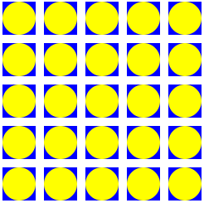
Get Ready
- Add a comment
'Tile Animation
Add Your Code
- Using FOR loops, draw 5 rows of 5 rectangles each on the screen
y = 50
For j = 1 To 5
For i = 1 To 5
GraphicsWindow.BrushColor = "Blue"
GraphicsWindow.FillRectangle(i * 50, y, 40, 40)
program.delay(100)
EndFor
y = y + 50
EndFor
- Using FOR loops, draw circles inside the rectangles
y = 50
For j = 1 To 5
For i = 1 To 5
GraphicsWindow.BrushColor = "Yellow"
GraphicsWindow.FillEllipse(i * 50, y, 40, 40)
program.delay(100)
EndFor
y = y + 50
EndFor
Try It Out!
- Click on Save. Click on Run and see what happens.
Challenge!
Background Color
Set the background color to Black
Random colors
Change rectangle and ellipse brush color to random colors
GraphicsWindow.GetRandomColor()
Grid size
Change grid to 10 rows X 10 columns
Numbers – New Project
Using a FOR loop, print numbers 1 to 20
Test Yourself!
In code snippet below, why is FOR loop used?
For n = 1 To 10
TextWindow.WriteLine(n)
EndFor
To repeat code 10 times
To check if n = 1

